New Delhi, India

02 Aug, 2024

INCEPTION REPORT

*Vegetable Irrigation for Climate Resilience Toolkit (VICT) Platform*

**Revision History**

| Name | Date | Reasons of Changes | Version |
| --- | --- | --- | --- |
| iTM | 02 Aug 2024 | The first draft of the document developed. | r1 |

Table of Contents

**1.0 Introduction 3**

1.1 Purpose 3

1.2 Scope 4

1.3 Definition, Acronyms and Abbreviations 5

**2.0 Overall Description 6**

2.1 System Perspective 6

2.2 System Functions 6

2.3 User Classes and Characteristics 7

2.4 Operating Environment 7

2.5 Design and Implementation Constraint 9

2.6 Assumptions and Dependencies 9

**3.0 Specific Requirements 11**

3.1 Functional Requirements 11

*3.1.1 Data Structure 11*

*3.1.2 Geographical Coverage Entities 12*

*3.1.3 User 13*

*3.1.3 System Features 15*

*A.1 HOME 18*

*A.2 EXPLORE DATA 18*

*A.3 INFORMATION 19*

*A.4 CONTACT 19*

*A.5 SEARCH 19*

*B.1 LOGIN 20*

*B.2 DATA SUMMARY 20*

*B.3 DATA 21*

*B.4 CONTENT 22*

*B.5 ADMIN 22*

3.2 Non-Functional Requirements 23

*3.2.1 Security Requirement 23*

*3.2.2 Usability and External Interface Requirement 24*

**Annexure A: Project Plan 25**

**Annexure B: Data Dictionary 27**

**Annexure C: Data Flow Diagrams (DFD) 30**

**Annexure D: System Architecture 33**

**Annexure E: Software Architecture 34**

**Annexure F: System Screens 35**

# 1.0 Introduction

## 1.1 Purpose

Increasingly severe and frequent extreme weather events globally are directly affecting food security and livelihoods for millions, especially in politically unstable regions. These events disrupt agricultural supply chains, including seeds, fertilizers, and equipment. Hence, strengthening the local food systems is crucial to ensure access to nutritious food during crises which requires systematic interventions to implement solutions through a comprehensive approach.

The Vegetable Irrigation for Climate Resilience Toolkit (**VICT**) platform aims to meet these challenges by providing a comprehensive and data-driven, evidence-based approach to support humanitarian agencies in designing and implementing irrigation investments for vegetable production. By promoting localized irrigation systems, the VICT platform will enable farmers to cope with the climate shocks and enhance food security in humanitarian contexts.

The VICT platform will be developed under the supervision of the International Water Management Institute (IWMI), a CGIAR Research Center, in collaboration with humanitarian organizations. It aims to integrate data-driven decision-making tools, provide actionable insights on water resource management, and support sustainable agricultural practices during crises. By using this platform, humanitarian agencies can better plan and support vegetable farming projects that will help communities become more self-sufficient, secure nutritious food, and reduce their reliance on emergency food aid.

The platform will have a central repository to store the collated data by geographical areas from data sources and time periods. It will consolidate all the tools relevant to the successful implementation of the best practice guidelines for irrigated vegetable production with special emphasis on water resource availability, use, and monitoring, irrigation technology design, enabling environment analysis etc. The platform will facilitate the implementation of localized investments in irrigation for vegetable production affected by humanitarian crises.

The purpose of this document is to provide the details of the project and guide the process of developing the VICT platform. It describes the functional and non-functional requirements of the platform. It serves as a communication bridge between stakeholders, developers, and testers. This document is in compliance with ISO/IEC/IEEE 29148:2018 standard.

The document comprises the system scope, overview, and features along with the system design. It comprehends the system architecture by following the Data Flow Diagrams, System and Software Architecture, and System Screens provided in the Annexures.

## 1.2 Scope

The platform will be developed using the open-source software technologies to ensure easy adaptability, usability, and scalability. It will have role-based access to create and manage the underlying database and its elements. It will be designed to cater the needs of the key stakeholders and will have responsive web design to support display on various screen sizes including that of computers, tablets, and mobile devices. The design and development team will work closely under the guidance of the project team during the development and implementation cycle.

The key tasks in the scope are:

* Develop an online repository of best practices, case studies, guidelines, resources and research content in the field of irrigated vegetable production in humanitarian settings, and integrate them into the web-based platform in a user-friendly manner.
* Develop a robust, data-driven backend for the platform that utilizes pre-computed multi-criteria decision-making and machine learning approaches, enabling dynamic and evidence-based decision-making for humanitarian interventions.
* Incorporate geospatial analysis capabilities into the platform, allowing the targeting of suitable areas for irrigated vegetable production based on a range of biophysical and socio-economic indicators.
* Ensure the platform provides actionable insights on water resource availability, use, and monitoring, as well as irrigation technology design, thereby contributing to the broader enabling environment for sustainable water management in crisis settings.
* Provide technical support during feedback sessions and incorporate recommendations from humanitarian organizations into the platform.
* Develop user manuals and online help options in the platform. Build capacity of the stakeholders on using and managing the platform, and its data.
* Provide a user feedback mechanism within the platform that allows for user experience and toolkit performance monitoring, thereby facilitating improvement.
* Establish a technical support system for the platform, offering timely assistance and guidance to users in ensuring maintaining operability of the platform’s features and functionalities.
* Ensure mobile compatibility of all the platform features and low bandwidth ability, ensuring offline usability.

## 1.3 Definition, Acronyms and Abbreviations

| # | Item | Description |
| --- | --- | --- |
| 1 | VICT | Vegetable Irrigation for Climate Resilience Toolkit |
| 2 | CSRF | Cross-site Request Forgery |
| 3 | CSV | Comma Separated Value |
| 4 | IWMI | International Water Management Institute |
| 5 | CGIAR | Consortium of International Agricultural Research Centers |
| 6 | DFD | Data Flow Diagram |
| 8 | GB | Giga byte |
| 9 | GeoJSON | Geographical JavaScript Object Notation |
| 10 | GIS | Geographical Information System |
| 11 | HTTPS | Hypertext Transfer Protocol Security |
| 12 | IEC | International Electrotechnical Commission |
| 13 | IEEE | Institute of Electrical and Electronics Engineers |
| 14 | ISO | International Organization for Standardization |
| 15 | JPG | Joint Photographic Experts Group |
| 16 | Mbps | Megabits per second |
| 17 | SRS | Software Requirement Specification |
| 18 | SSD | Solid State Drive |
| 19 | UI | User Interface |
| 20 | UI/UX | User Interface/User experience |
| 21 | vCPU | Virtual Central Processing Unit |
| 22 | VM | Virtual Machine |
| 23 | FAQ | Frequently Asked Questions |

# 2.0 Overall Description

## 2.1 System Perspective

The VICT platform will be a web-based platform that will use a data-driven, evidence-based approach to support humanitarian agencies in designing and implementing irrigation investments for vegetable production. The platform will feature interactive visualizations and analysis to present the data.

The platform will integrate data from various sources and utilize advanced analytical techniques to facilitate evidence-based decision-making for irrigation investments. It will provide interactive features such as data visualization and geospatial analysis capabilities to enable users in identifying suitable areas for vegetable farming and optimizing irrigation practices. It will server as a content repository that consolidates existing research, case studies, and best practices in the field of irrigated vegetable production in humanitarian settings.

## 2.2 System Functions

The platform will comprise of the two applications, the **User Interface** and the **Data Manager**. The Data Manager application will be accessed by valid login credentials, whereas the User Interface will be accessed without a login.

The platform will provide functions for:

1. Content Management: Documents management and categorization.
2. Data Import: bulk data import from data sources.
3. Data Processing: Data cleaning and validation.
4. Data Visualization: Interactive charts, graphs, and maps.
5. Data Analysis: Analyze data at various levels.
6. User Management: Role-based access.

The User Interface application will allow users to access, analyze, and visualize data stored in the central database. The Data Manager application will allow the management of the underlying database with modules to manage data import, data verification, data approval, content management and user management. The platform will import both from the CSV formatted files.

Following will be the core features of the platform:

* Stores and manages the variables-based data and metadata.
* Manages geographical areas and their respective maps at national and sub-national levels.
* Allows to upload and enter data for the variables by various dimensions and geographic areas at national and sub-national levels.
* Consolidate, approve and present data using the advanced data visualizations for better analysis.
* Allows to download and print visualizations of underlying data in various formats.
* Allows uploading and updating data using industry-standard formats like CSV.
* Present water resource availability and vegetation data using geospatial maps for better decision making.
* Facilitate effective data import, monitoring, and analysis of the impact and effectiveness of irrigation investments for vegetable production.
* Allow to search and filter data to enable users to view relevant data and insights for specific geographical areas and relevant dimensions.
* Present content by category which will include best practices, case studies, guidelines, resources and research.
* Allow the users to fill an enquiry form to send questions or feedback that will facilitate improvement in the platform.

## 2.3 User Classes and Characteristics

The following are the category of users with their expected requirements from the platform:

* Humanitarian Agencies
  + Require information on best practices for implementing irrigation projects.
* Local Government and Policymakers
  + Need easy-to-understand data focused on agricultural development, water resource management and climate resilience to inform decision-making.
* Researchers
  + Require access to raw datasets for conducting studies and validating research hypotheses.
* Individual and Farmers
  + Need simplified and accessible information to invest in micro-irrigation systems, enhancing their food production, income, and self-reliance.

## 2.4 Operating Environment

The platform will be hosted on the cloud-based servers and it will be accessible via web browsers on desktop and mobile devices. It will be compatible with major browsers such as Chrome, Firefox, Safari, and Edge. Following will be the requirements to deploy the platform:

* Reliable and scalable web/application server such as Apache, Tomcat.
* Database server to host the database such as MongoDB.
* Cloud infrastructure such as AWS, Other cloud services.
* Operating systems such as Ubuntu and other software components to host the platform.
* Version control system to manage code such as GitLab.
* SSL/TLS certificate to secure data transmission between users and the web server.
* Public IP and domain.
* Firewall to protect the network and systems from unauthorized access and attacks.
* Scripts to take regular backups and a robust disaster recovery plan.
* Stable internet connection.

The platform will be deployed in the cloud on the Virtual Machines (VMs). It is recommended to deploy the application and database on separate VMs.

| # of VMs | Purpose |
| --- | --- |
| 1 | To host the user interface and the data manager application |
| 1 | To host the central database |

Each VM is recommended to have the following specifications:

Processor 8 vCPU

Memory 16 GB

Storage 500 GB SSD

Internet Connection 100 Mbps recommended

Ports80, 27017, 6379, 443, 21, 22

Web servers shall be protected by the firewall. A public IP and dedicated domain will be needed. A web master shall be assigned the task of managing, troubleshooting and maintaining the web server. There shall be adequate uptime of the web server. A decent internet connection will be required for the web server to manage the expected network traffic.

*Note: The above specifications are recommended requirements, though the platform will be able to be deployed on lower specification web-based instance with options of elastic storage and processor. Port 80 would be required only during the development process*

## 2.5 Design and Implementation Constraint

The platform will be developed using the following open-source technology and tools that will allow easy extensibility and scalable communication interfaces. The platform will use the HTTP protocol for communication over the internet. Below will be the technology stack that lists the following programming environment and tools. See **Annexure E: Software Architecture**.

Operating Tool Ubuntu (RHEL) v 20.04

Front-end Language HTML v5.0, CSS v3.0, JavaScript ES2022

Visualization Library ECharts v5.4.0, Leaflet v1.9.3

Front-end Framework Angular v16

Back-end Language Node.js v18.1.0, PHP v7.4

Back-end Framework Express v4.16.2, Laravel v8.11.2

Database Tool MongoDB v5.0

Server Type Apache v2.4*, Docker v20.10.7, Docker composer v1.27.0

Data will be imported from Comma Separated Value (CSV files).

The platform will be designed to handle a large number of concurrent users and large volumes of data without performance degradation. The application can be integrated with various existing databases and external data sources through APIs. The platform will load within a few seconds and provide near real-time updates to ensure timely access to data.

## 2.6 Assumptions and Dependencies

It is assumed that all required data from various sources, managed by respective government ministries, departments, and agencies, will be available and accessible. The data provided by different sources will be accurate, up-to-date, and formatted to meet the platform’s standard data entry requirements. Users are expected to have reliable internet access and modern web browsers that support the platform functionalities. Cooperation from all relevant stakeholders, including data providers and end-users, is crucial for providing necessary inputs and feedback during the development and deployment phases.

The functionality of the platform depends on timely and continuous data feeds from various sources. Any disruption or delay in data provision can impact the platform’s accuracy and usefulness.

The technology stack used in the development of this platform will include stable and actively maintained open-source libraries and frameworks. Any major changes or discontinuation of these technologies could affect the project. Successful deployment and adoption of the platform will depend on adequate training and support for end-users, including humanitarian agencies, government officials, researchers, and the general public.

# 3.0 Specific Requirements

## 3.1 Functional Requirements

### 3.1.1 Data Structure

The platform will be developed to store and manage the variable-based data. The data structure will be comprised of the following elements-

**Indicator**: A series of observations with harmonized characteristics representing a standard behavior. Example Total Sustainable Area.

**Metadata**: Detailed explanation of the series following the global standard for data definition. Example Definition. Method of Computation.

**Unit of Measurement**: Measurement scale of the observation value. Example Hectare (ha).

**Subgroup**: Disaggregated group to represent further dimensions of the observation. Example Season.

**Indicator-Unit-Subgroup Combination**: Besides defining the disaggregation for each indicator it is also used to define the target group of an indicator. Example – Groundwater irrigated area – Hector-Dry.

**Sector/Subsector**: Termed as Indicator Classification that groups similar indicators for organized storage and reporting. Example Vegetation. Further classification within a sector for lower-level groups of similar indicators.

**Observation/Date Value**: Report and store data against a combination of Indicator – Unit – Subgroup (IUS).

**Area**: Geographical or administrative boundaries to represent the data values for each IUS combination. Example: Country, Region, Woredas etc.

**Time Period**: Reported time period of the data values for each IUS combination. Example 2017, 2016-2017. The time period represents the day, week, month, quarter, year and year range.

**Source**: Data source of the reported data values for each IUS combination.

Below will be the data structure diagram of the underlying database: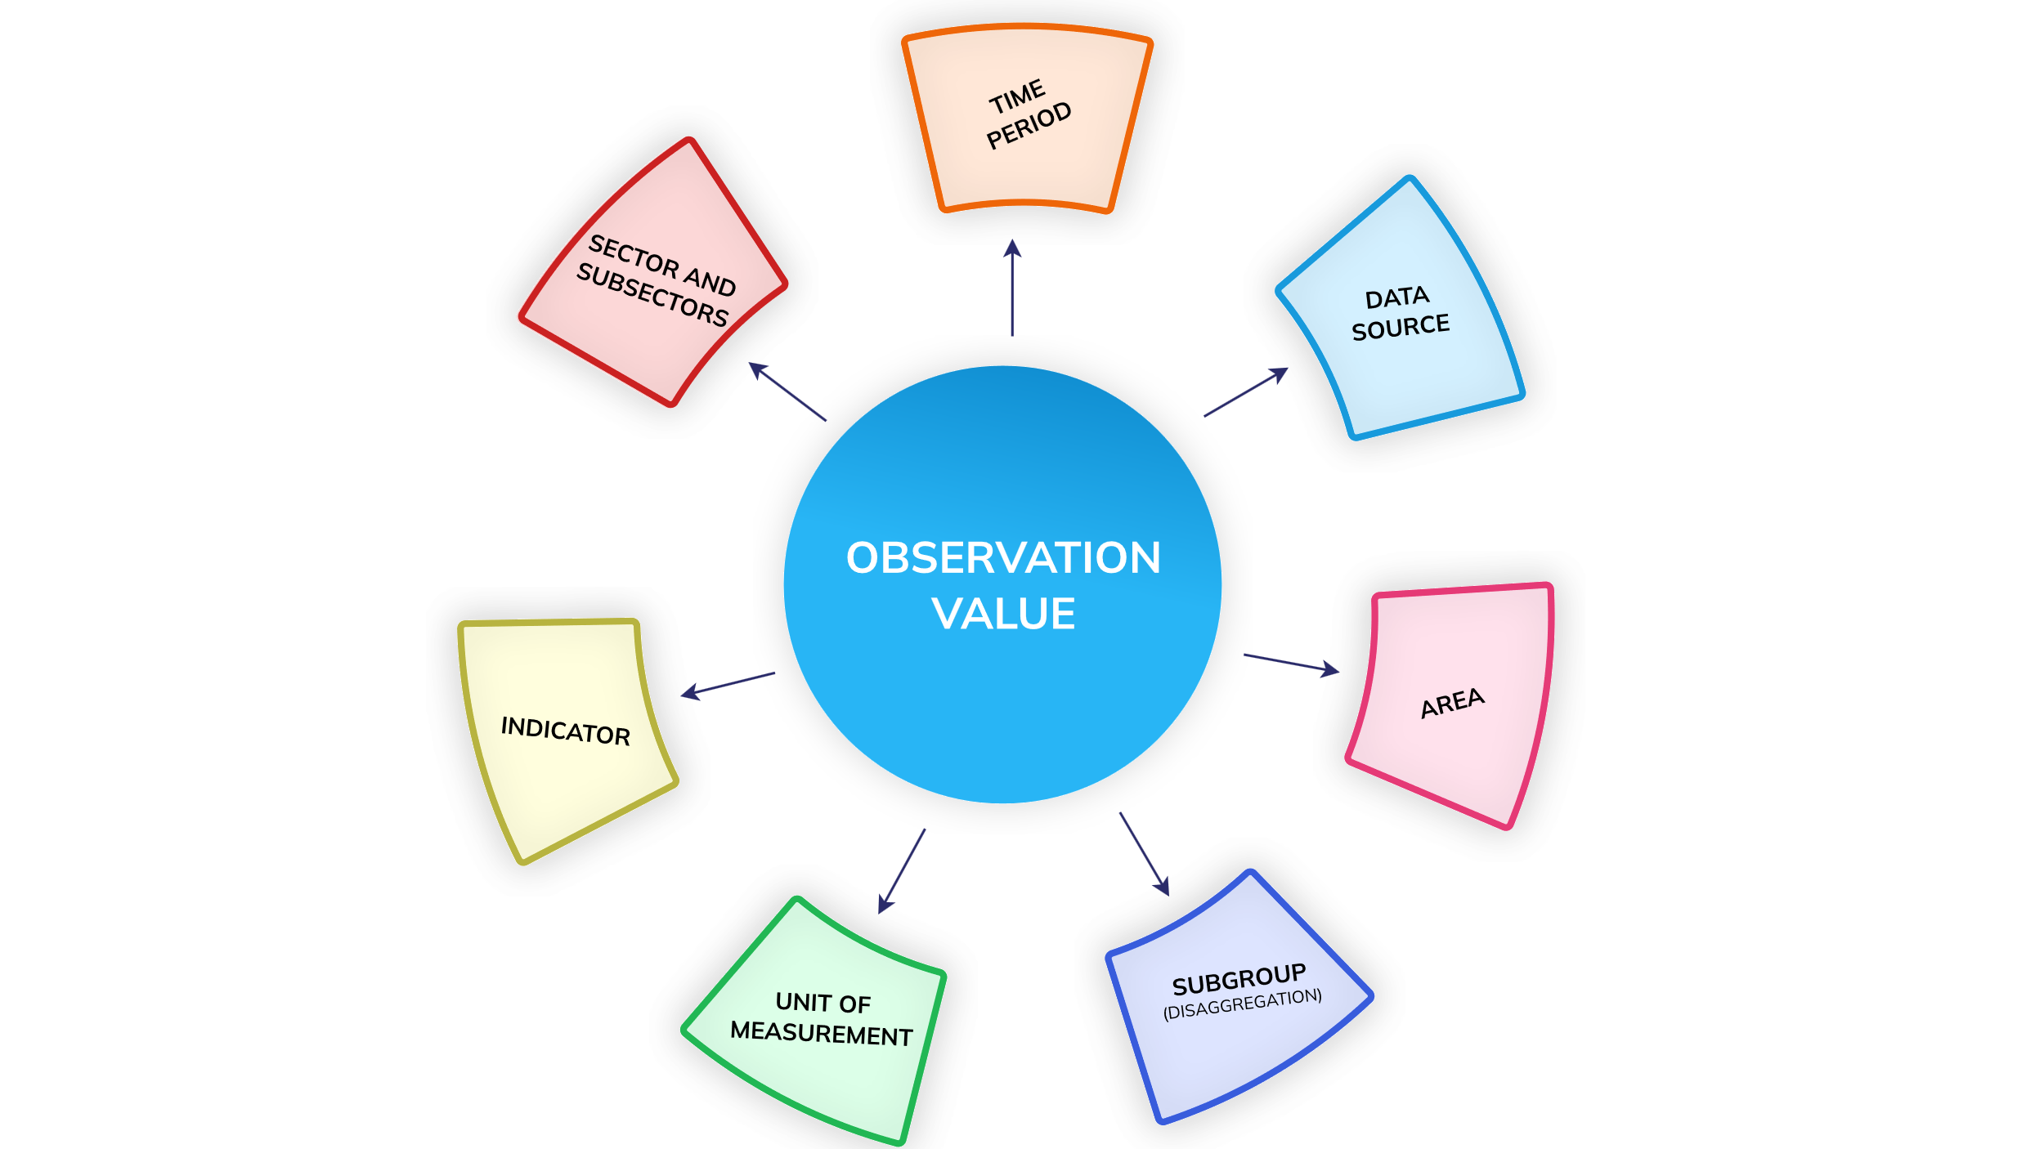

### 3.1.2 Geographical Coverage Entities

The platform will be developed to store and manage data at various geographical levels or administrative boundaries. The geographical level is termed as Area. The data manager application has a module to manage Areas and their geo-spatial maps. The dashboard is capable to manage the area at following level -

* National - This level pertains to the country that is Ethiopia and Mali . The platform will accommodate data storage and management for related indicators at the national level.
* Sub-national - At this level, the platform allows for data management at sub-national levels within both the countries. It supports the storage and organization of data specific to different regions and woredas.

This will enable efficient data handling and analysis of data at both the national and sub-national levels, ensuring that information is appropriately organized and accessible according to the geographical context. As explained in the data structure section the data values will have an area dimension which will refer to the geographical area for which the data is entered. Example: The application will have provisions to enter Groundwater irrigated area in hectares at national, state, and district levels for various time periods and data sources. This helps in data analysis and comparison at all geographical levels of various indicators.

The data manager application allows to manage area and their GIS maps. Each area will have the following details –

* Area ID
* Area name
* Area Level
* Area Parent ID

For each area entered/imported there will be map associated. Area ID will be the common key between the area master and the related maps. One or more maps can be related to one area id to manage the chorological maps of same area which may have changed due to area split or merge. One or more maps associated to the same area will be distinguished by having a different start and end date for each shape. The maps will be managed in GeoJSON format file and will be stored in the application server. Users will be able to search and view the data in thematic maps based on the selected area and time period.

### 3.1.3 User

The platform will have role-based access to the various modules and will allow to create and manage various users and assign them roles. The users of the platform will be responsible to enter and approve data for their assigned geographical areas and indicators. The platform administrator will create users for data entry and data approval roles. These users will login with their respective credentials. While the data entry user will enter data for their assigned area, the data approval user will check and mark the data as approved or disapprove data and enter remark for disapproval. For the disapproved data, the data entry user will be able to edit and re-submit the corrected data for approval. The approved data will then be viewed in the user interface modules of the platform.

Following type of users will be available in the platform

1. Administrator
2. Data Entry
3. Data Approve

**Administrator**

Administrator will be the first user of the application and will be pre-created with administrative privileges. Administrator will have full access to all modules and will have the capability to create additional users and assign specific roles to them.

**Data Entry**

Data Entry users will be allowed to import or enter data for their assigned area. They will also be allowed to edit and manage the data they have entered.

**Data Approver**

Data Approver users will be allowed to view, approve or disapprove the data entered by the data entry users. They will be able to manage the data approval process for their assigned area.

Below is the user roles diagram: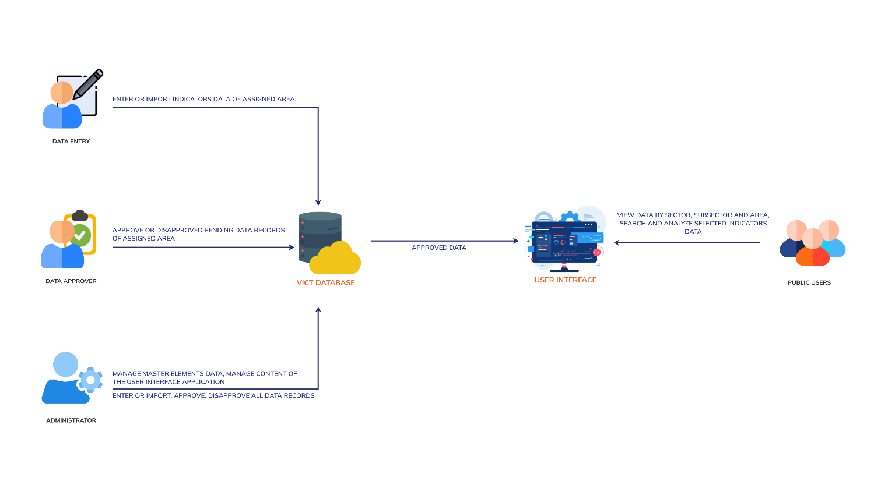

### 3.1.3 System Features

The platform will be comprised of the following two applications -

1. User Interface
2. Data Manager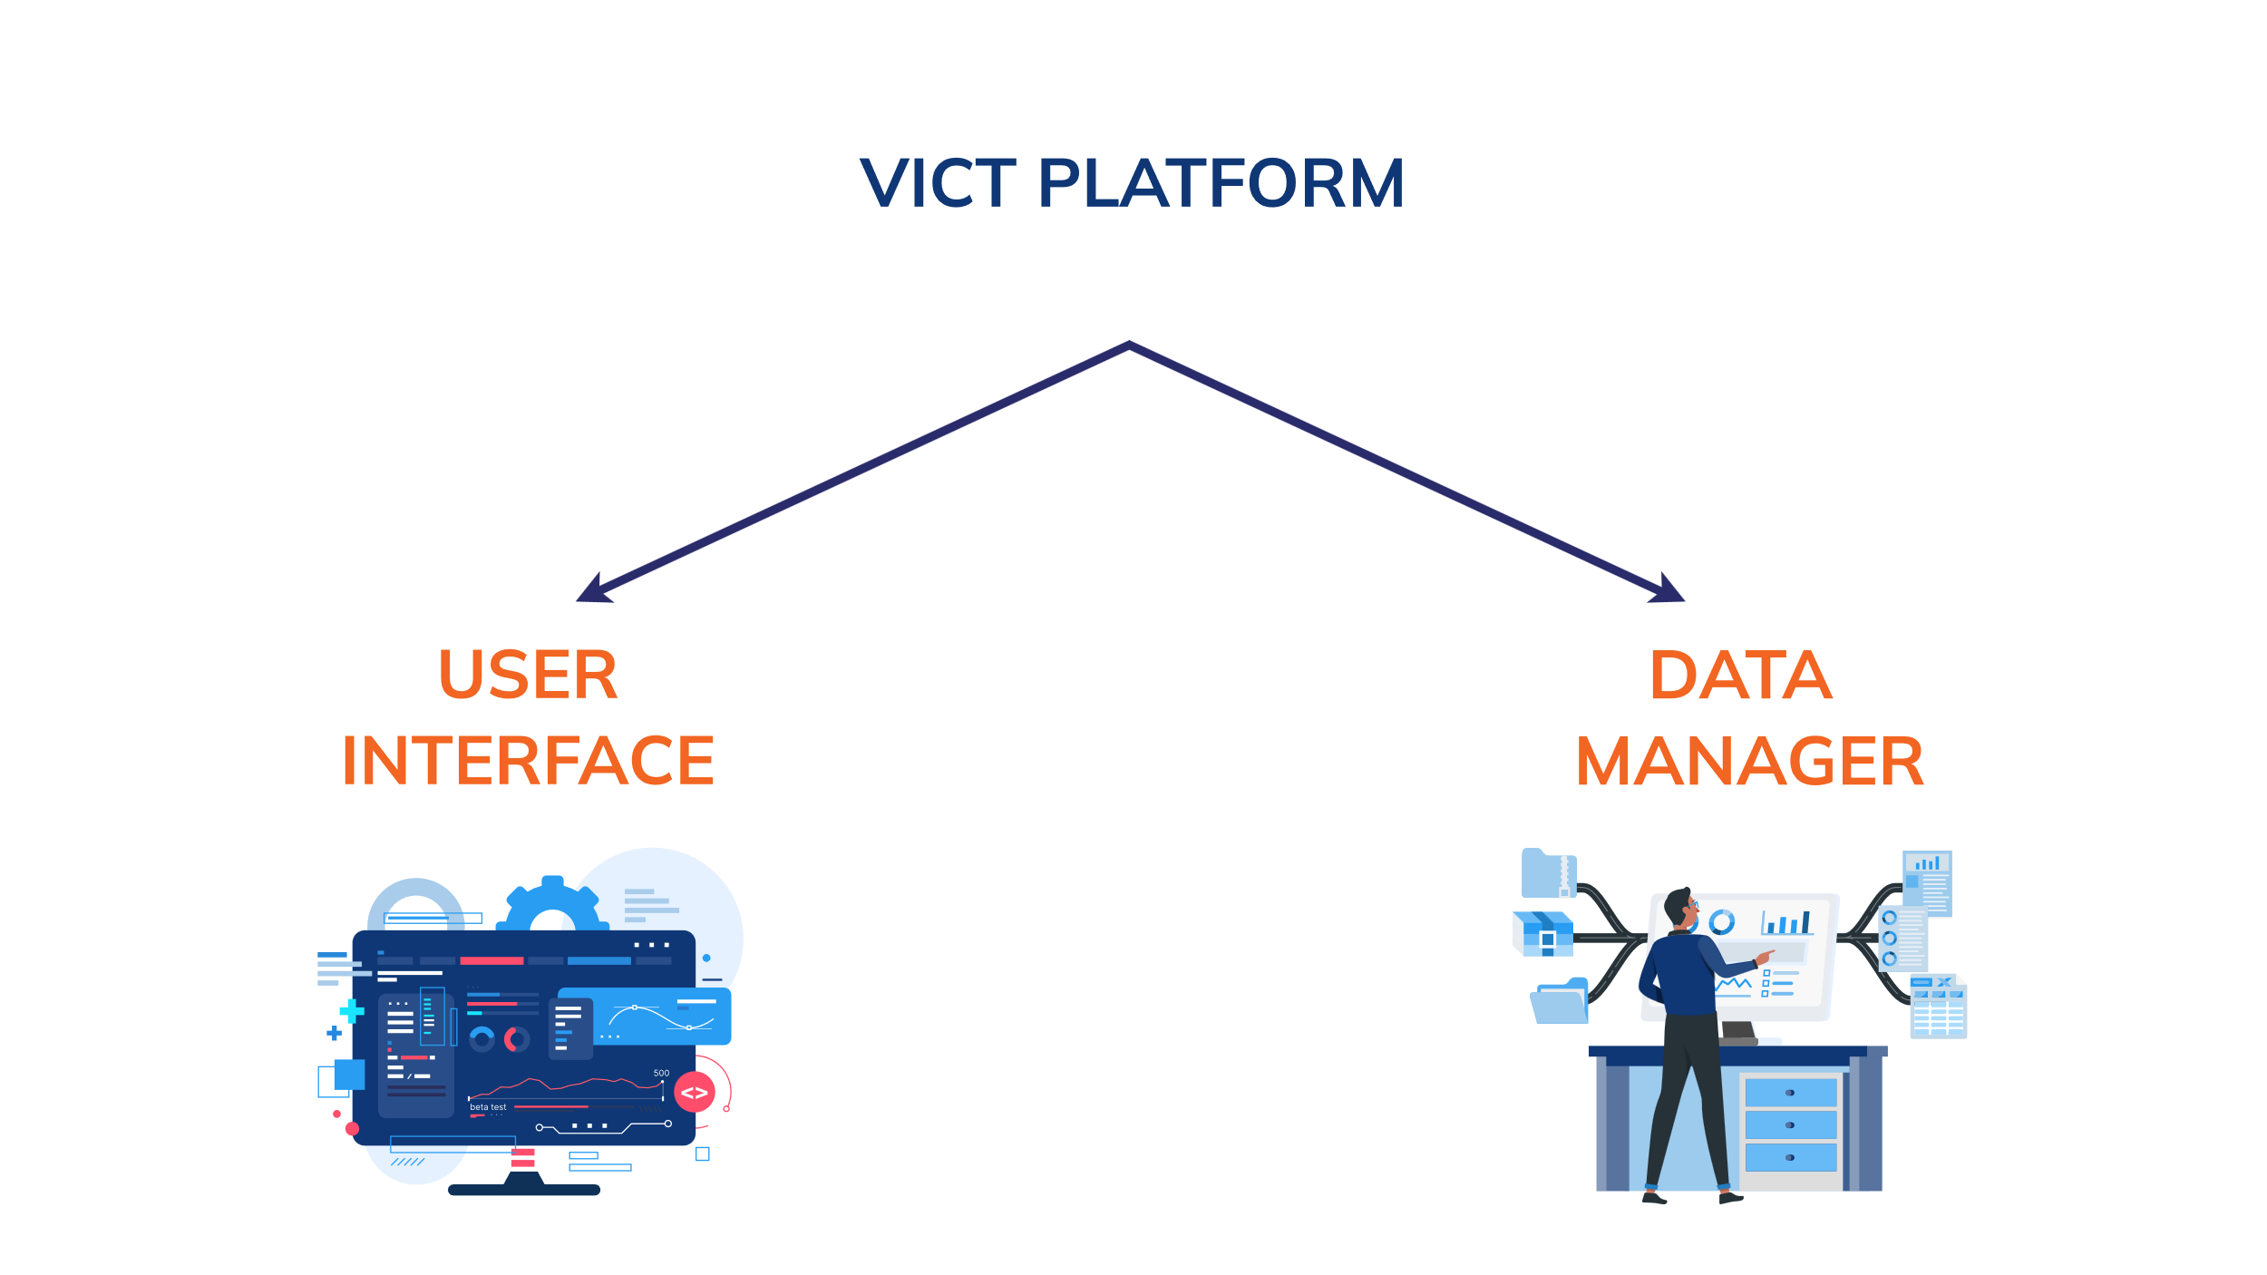

The below diagram depicts the modules and submodules of the user interface application.

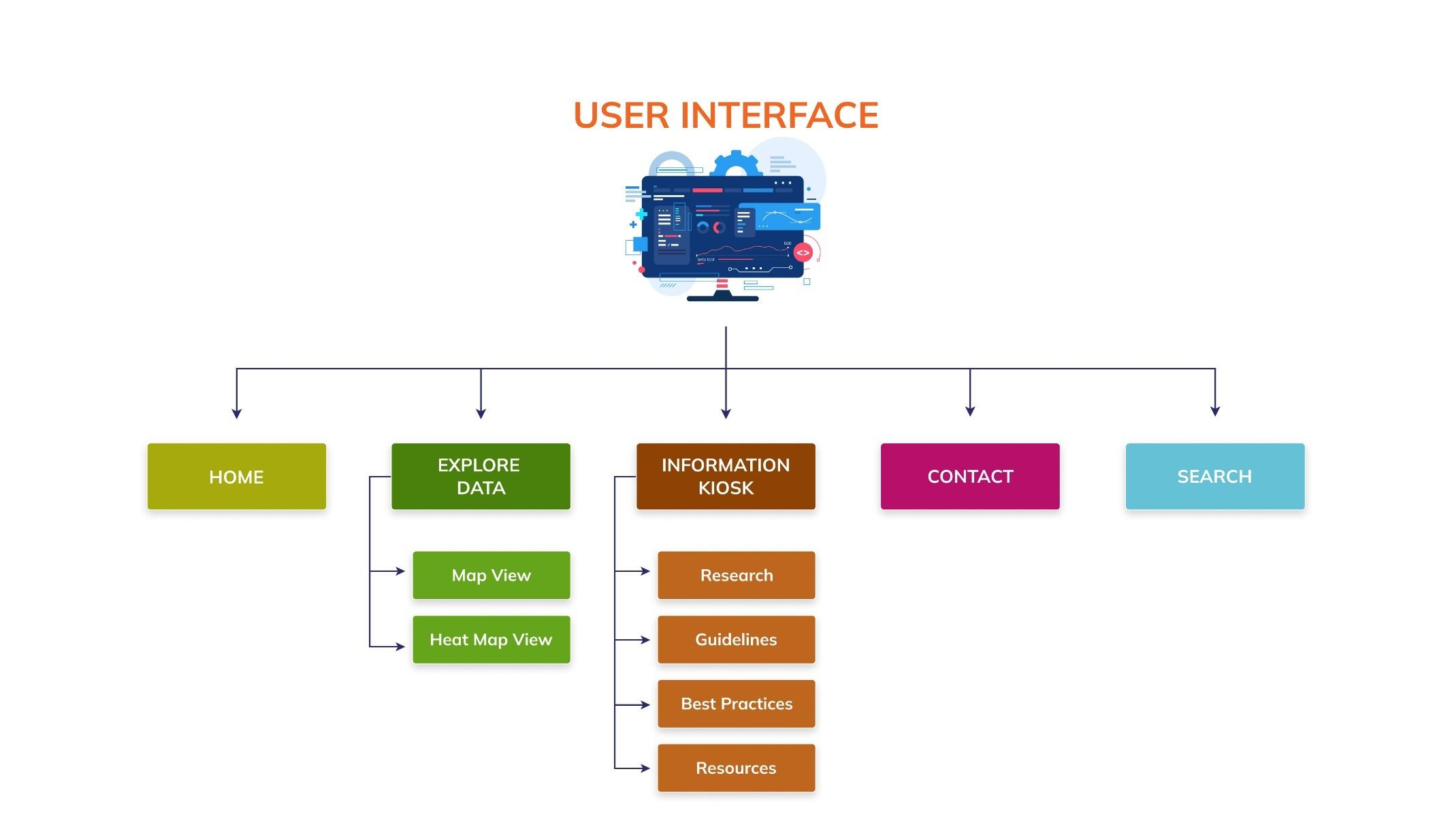

The below diagram depicts the modules and submodules of the data manager application.

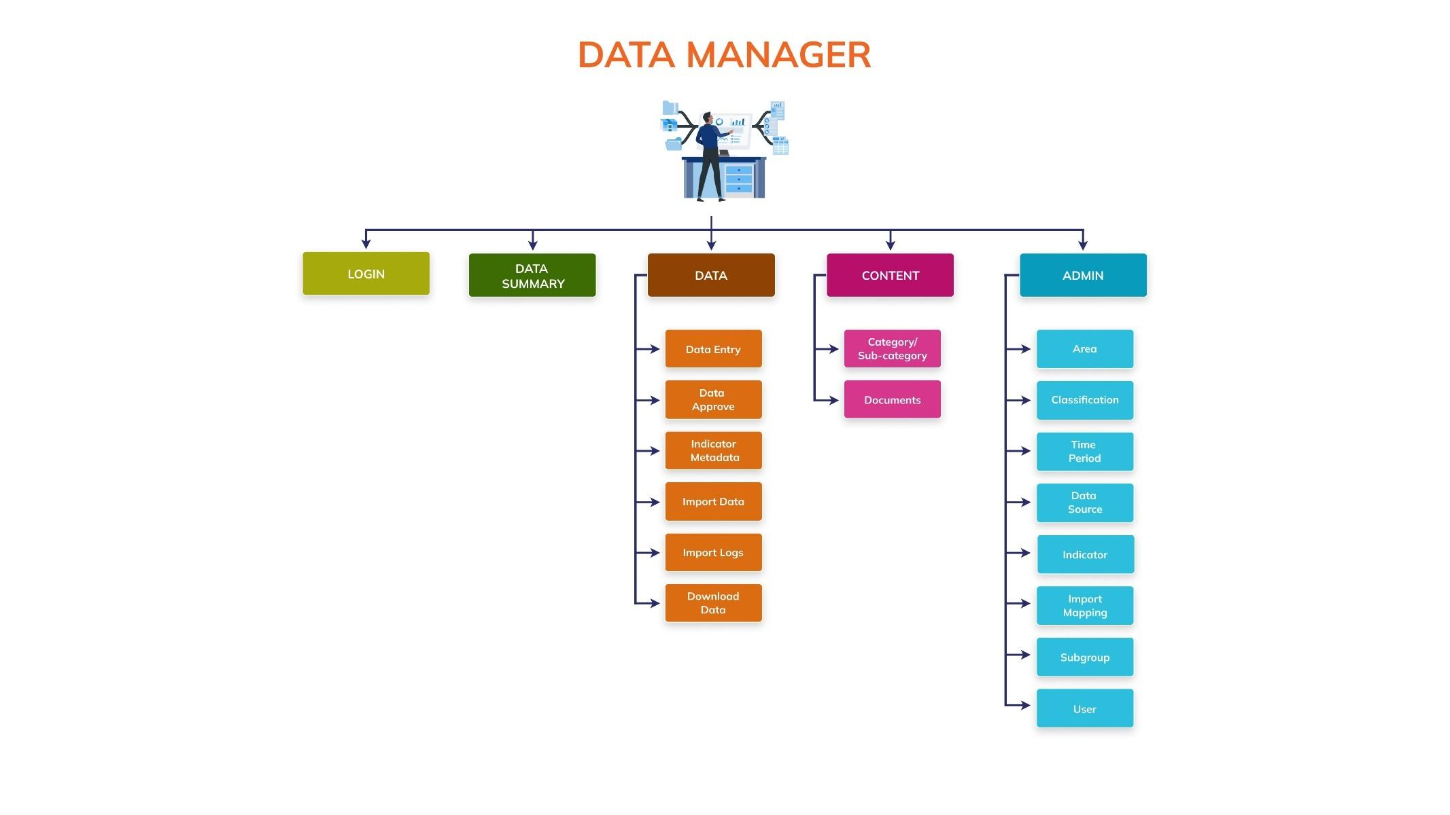

1. **USER INTERFACE**

The User Interface application will comprise of the following modules and sub-modules. See Annexure **C: Data Flow Diagram (DFD)** for input – process – output flow details of the system and See **Annexure D: System Architecture** for interaction between modules.

1. Home
2. Explore Data

* Map View
* Heat View

1. Information
2. Contact
3. Search

### A.1 HOME

This will be the landing page of the platform which will have header, body and footer sections. The header section will contain the branding logo and burger menu option to navigate to other modules and their sub-modules. The body section will have context related photos/videos and project title. The footer section will contain contact details, privacy policy, terms of use and copyright statement**.**

### A.2 EXPLORE DATA

This module consists of two submodules: Map View and Heat Map View. Both submodules are driven by area, crop water requirements, and season. They will present indicators and drivers data using a multi-dimensional map of the selected area and a heat map. Users will be able to navigate through a hierarchical list of areas, search, and select geographical areas to view the respective data. Below is the brief description of the both the submodules:

#### **A.2.1 Map View**

This view will present the data of suitability for vegetable irrigation on a multi-dimensional map of the selected area. The map will be color-coded to indicate different levels of suitability for sustainable irrigation areas, with darker colors representing higher suitability. Selected drivers' data, such as flood frequency will be overlaid on the map using color coded dots, contributing to the visual representation of irrigation suitability. The legends will be available at the bottom along with the source of the data. There will be a toolbar in the left which will allow you to zoom in, zoom out, reset, on/off label, show/hide north symbol and download the map data. Clicking on a specific area on the map will present a detailed area profile on the right-hand side. This will include total area, area suitable for vegetables, rainfed area, groundwater, and surface water availability. A table will list various irrigation technologies, their suitability for groundwater and surface water sources, and their respective distances and depths. Suitable technologies will be marked with a green check, while unsuitable ones will be marked with a red cross. There will also be an option to download the selected data.

#### **A.2.2 Heat Map View**

This view will present the selected data using a heat map visualization. Each row will represent a different subnational area, and each column represents a driver related to sustainable irrigation. The cells are color-coded to indicate the suitability or presence of each driver, with green representing favorable conditions and red representing less favorable conditions. This visual representation will allow users to compare different subnational areas across various drivers. There will also be an option to download the selected data.

### A.3 INFORMATION

The information module will allow users to view and download reference documents and related information categorized into various categories such as Best Practices, Guidelines, Research and Resources. The module will feature a banner image at the top of the resources page. Each resource will have an image, name, description, and either a link to view more details or an attached document. A search option will be provided to help users filter resources according to their needs.

### A.4 CONTACT

This module will allow users to access contact information of the support desk of the platform. Users will also have the option to fill out a contact form by entering their name, email address, subject, and message, and submit their inquiry.

### A.5 SEARCH

This will be a free search which will allow us to search the data available in the database. You can click on the elements of the searched results to view the visualization widgets of all the indicator-unit combinations of the selected sector.

1. **DATA MANAGER**

Access to this application is restricted, allowing only users with valid login credentials to access the application. The Data Manager application comprises the following modules and submodules.

1. Login
2. Data Summary
3. Data

* Data Entry
* Data Approve
* Indicator Metadata
* Import Data
* Import Logs
* Download Data

1. Content

* About
* FAQ
* Guidelines
* Import Data
* Reference Links

1. Admin

* Area
* Classification
* Time period
* Data source
* Indicators
* Subgroup
* Import mapping
* Content Category
* User

Below is the description of these sub-modules in detail.

### B.1 LOGIN

This module will be the first access point to get into the data manager application. Users with valid credentials will be able to enter their email and password for authentication. There will be CAPTCHA to determine if an online user is really a human and not a bot. The platform administrator will be responsible for creating and managing other users of the platform.

### B.2 DATA SUMMARY

This module will be the landing page after successful login into the data manager application. This allows users to view the number of records available for all the key elements of the database for example – User, Indicator, Data Value.

### B.3 DATA

This module will comprise six sub-modules – Data Entry, Data Approve, Indicator Metadata, Import Data, Import Logs and Download Data. Below is the brief description of the submodules of the data module.

#### **B.3.1 DATA ENTRY**

This sub-module will allow authorized users to manage indicators data. User will have options to view the data records, update and delete the existing data. The data records will be shown in tabular grid by status Pending, Approved and Disapproved. The data when imported will be added in pending list of data records. Only the approved data records will be shown on the dashboard.

#### **B.3.2 DATA APPROVE**

This sub-module will allow authorized users to manage approval process of indicator’s data. User will have options to approve or disapprove a data record or approve all pending records. Only the approved data will be displayed on the user interface application.

#### **B.3.3 INDICATOR METADATA**

This sub-module will allow authorized users to manage the indicator’s metadata. User will have options to export and import metadata data templates, view, search, sort and show/hide the indicator’s metadata.

#### **B.3.4 IMPORT DATA**

The sub-module will allow the authorized users to manage indicator data by importing the indicator data files into the database. To perform this action there is an option to browse your data file and upload it into the database using Import feature. There are also options available to download empty data templates and data files available in the database. The import summary of the last uploaded file is shown in a tabular view.

#### **B.3.5 IMPORT LOG**

The sub-module will allow administrator and data entry users to view the import logs that are generated after the import process. Every bulk import operation of data will generate a log, which will report on the success and failure of the imported data records. User can access these logs to gain insights into the outcome of the import process, including details about successful imports and any encountered failures. While the administrator will be able to view and manage the all-import logs, the data entry user will only be able to manage their own import logs. Option will be available to download or delete the log.

#### **B.3.6 DOWNLOAD DATA**

The sub-module will allow authorized users to download the existing data in CSV formatted file. There will be options to download filter data using advance filter od download all data. You will have options edit, view and download the data files.

### B.4 CONTENT

This module will allow authorized users to manage the content of the Information module of the user interface application. The category of the content will be managed in the content category module. Based on the selected category you will have the option to upload document and image, insert URL, assign tags etc. You will have options to add, edit, view, search and sort and delete the selected content.

### B.5 ADMIN

This module will consist of seven sub-modules – Area, Classification, Time Period, Data Source, Indicator, Subgroup and User. This module will allow the administration and control of the core and foundational elements of the platform Below is the brief description of the submodules of the admin module.

#### **B.5.1 AREA**

This sub-module will allow authorized users to manage the geographical areas. User will have the options to export and import area templates, add, edit, view, search, sort and show/hide the geographical areas.

#### **B.5.2 CLASSIFICATION**

This sub-module will allow authorized users to effectively manage classifications within the database. User will have options to add new classifications, edit, delete, update status, and show the existing list of classifications based on their respective classification type.

#### **B.5.3 TIME PERIOD**

This sub-module will allow authorized users to manage the time periods of the data records. You will have the options to add, edit, view, search, sort and show/hide the time periods.

#### **B.5.4 DATA SOURCE**

This sub-module will allow authorized users to manage the data sources of indicator data. You will have the options to add, edit, view, search, sort and show/hide the data sources.

#### **B.5.5 INDICATOR**

Variables and drivers will be termed as Indicators in the platform. This sub-module will allow authorized users to manage the list of indicator-unit (IU). You will have options to view, search, sort and show/hide the indicators. Each indicator will be linked to its unit of measurement (Unit).

#### **B.5.6 SUBGROUP**

This sub-module will allow authorized users to manage the list of subgroups also called Disaggregation and grouped under Subgroup Dimension. You will have options to add, edit, view, search, sort and show/hide the subgroups.

#### **B.5.7 IMPORT MAPPING**

This module will allow users to create and manage the data mapping utility for importing indicators data into the platform. User will have options to create mapping by specifying the correspondence between the target column and the mapped columns to import the respective data. There will also be options to manage existing mapping by updating, deleting, sorting the list and adding new import mapping

#### **B.5.8 CONTENT CATEGORY**

This sub-module will allow users to create and manage the category list of the content. You will have options to add, edit, view, search, sort and show/hide the content category.

#### **B.5.9 USER**

The sub-module will allow administrators to create and manage the users of the platform. The platform administrator will be the first user of the application and will be able to create and manage further users with role as Data Entry or Data Approver. There will be option to edit, delete and show/hide the user in the platform.

## 3.2 Non-Functional Requirements

### 3.2.1 Security Requirement

The application will enforce HTTPS for all data transmissions and will implement data encryption at rest and in transit. It will be ensured that all vulnerabilities of the web application are identified and corrective measures are taken. The web application environment including the scripting language, web server software, and the operating system are mentioned in this document. Configuration and coding will be done in the applications to manage the identified vulnerabilities. A manual testing will be conducted on the applications to ensure that no known vulnerabilities exist in the system. Below are some of the known vulnerabilities that will be handled in the applications:

* Displaying the passwords between client and server in clear text
* Session hijacking
* Cross-site request forgery (CSRF) attack to load a page containing malicious request
* Upload malicious (.exe) file
* Brute force attack
* Not maintaining audit trails
* Runtime/Server error
* View the authenticated page from the cache of the browser
* Server version disclosure in header response

### 3.2.2 Usability and External Interface Requirement

The platform will be compatible with the commonly used internet browsers including Google Chrome, Mozilla Firefox, Microsoft Edge and Apple Safari. The platform will be developed using open-source software development technologies and frameworks. The application will be easy to navigate and will have a menu-driven approach to access the modules based on the user permissions. The platform will be responsive and compatible with both desktop and mobile devices. It will be modern design principles for accessibility. There will be no specific hardware interface requirements as the application will be cloud-based. The application will be integrated with the underlying database via RESTful APIs and will allow exporting data in common formats like CSV and Excel. The applications will use REST APIs for communication between the frontend and backend.

# Annexure A: Project Plan

| **Tasks** | **Deliverable** | Jun-24 | Jul-24 | Aug-24 | Sep-24 |
| --- | --- | --- | --- | --- | --- |
| 1. Project Scoping, Definition, Background | Inception Report |  |  |  |  |
| 1.1 Information gathering |  |  |  |  |  |
| 1.2 Review and collate data, data collection tools, requirement |  |  |  |  |  |
| 2. System Requirements and Design | Functional Requirement Document (FRD) |  |  |  |  |
| 2.1 Define system modules and sub-modules |  |  |  |  |  |
| 2.2 Define the outlines findings, design and process flow |  |  |  |  |  |
| 2.3 Design and develop wireframes |  |  |  |  |  |
| 3. Database Development and Customization | Customized Database |  |  |  |  |
| 3.1 Customize data structure |  |  |  |  |  |
| 3.2 Prepare data templates and database |  |  |  |  |  |
| 4. System design and Development | System Development Completed |  |  |  |  |
| 4.1 Setup staging instance in the cloud (AWS instance) |  |  |  |  |  |
| 4.2 Develop data collection modules |  |  |  |  |  |
| 4.3 Deploy and test the data collection modules |  |  |  |  |  |
| 4.4 Develop User Interface Application |  |  |  |  |  |
| 4.5 Deploy and Test User Interface Application |  |  |  |  |  |
| 4.6 User Acceptance Testing (UAT) |  |  |  |  |  |
| 5. Knowledge transfer and capacity building | Trained Stakeholders |  |  |  |  |
| 5.1 Prepare training materials |  |  |  |  |  |
| 5.2 Conduct training of the stakeholders |  |  |  |  |  |
| 6. Deployment and Rollout | System Deployment Completed |  |  |  |  |
| 6.1 Setup production instance in the cloud (AWS instance) |  |  |  |  |  |
| 6.2 User Acceptance Testing (UAT) |  |  |  |  |  |
| 7. Support and Maintenance | Technical Support |  |  |  |  |
| 7.1 Trouble shooting and bug fixing |  |  |  |  |  |
|  |  |  |  |  |  |

# Annexure B: Data Dictionary

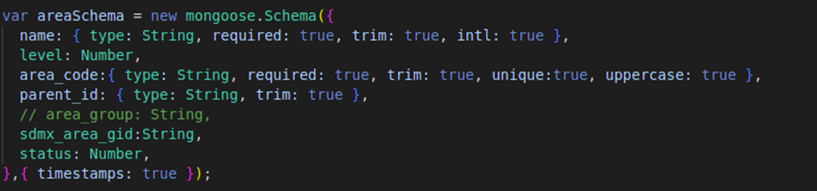**Manage Areas**

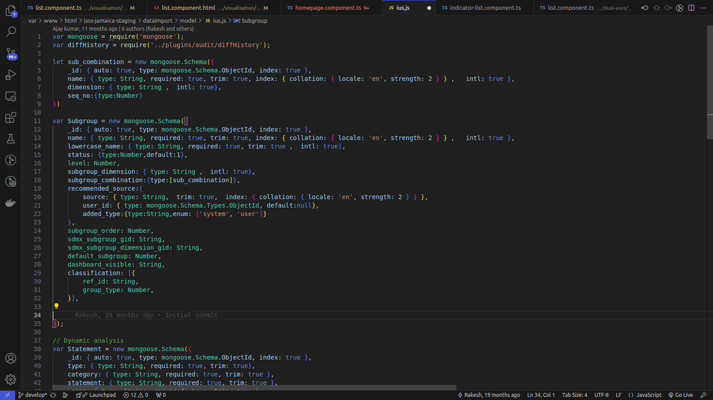**Manage Indicators**

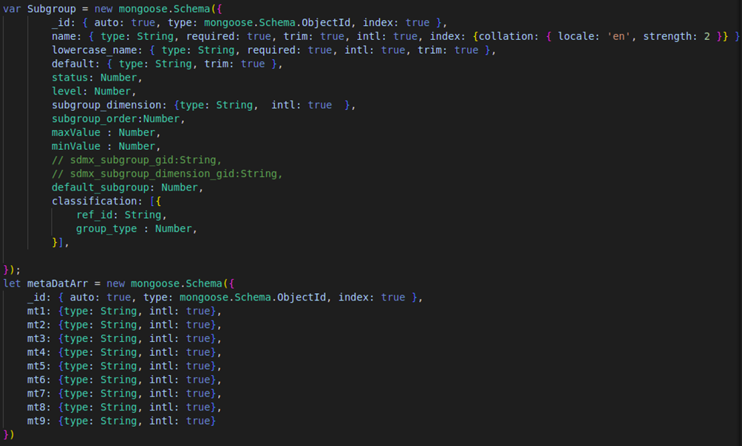**Manage Metadata**

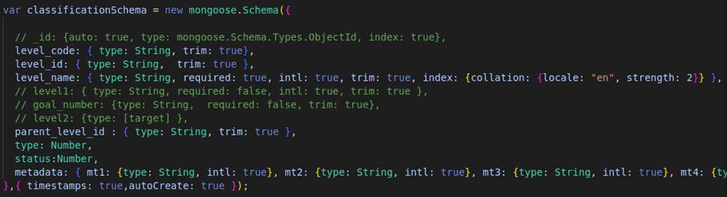**Indicator Classification**

**Data Source**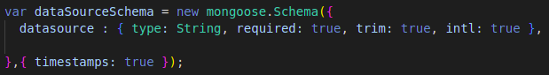

**Time Period**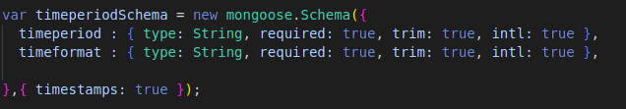

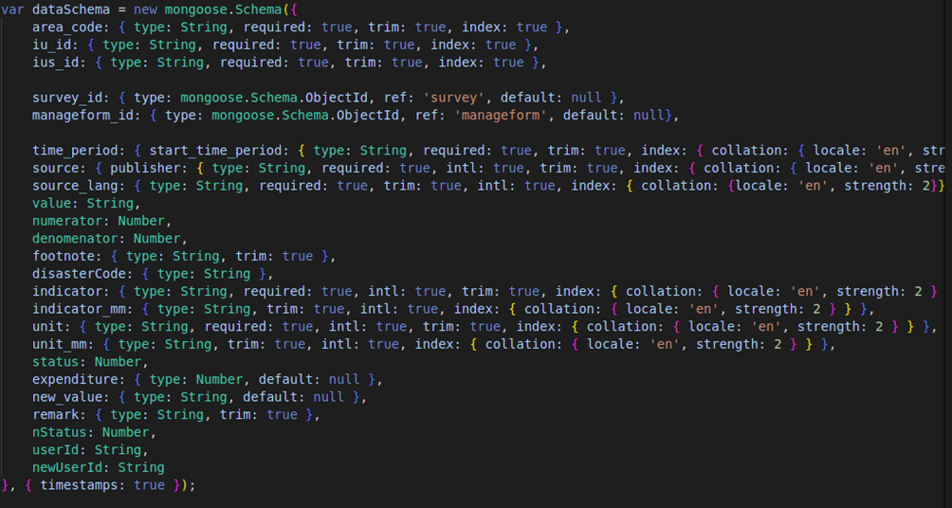**Manage Data**

# Annexure C: Data Flow Diagrams (DFD)

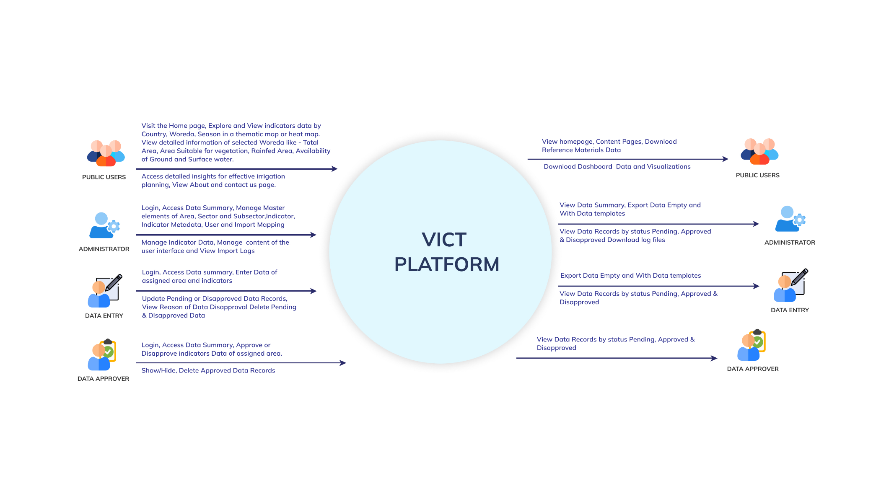**Level** **0**

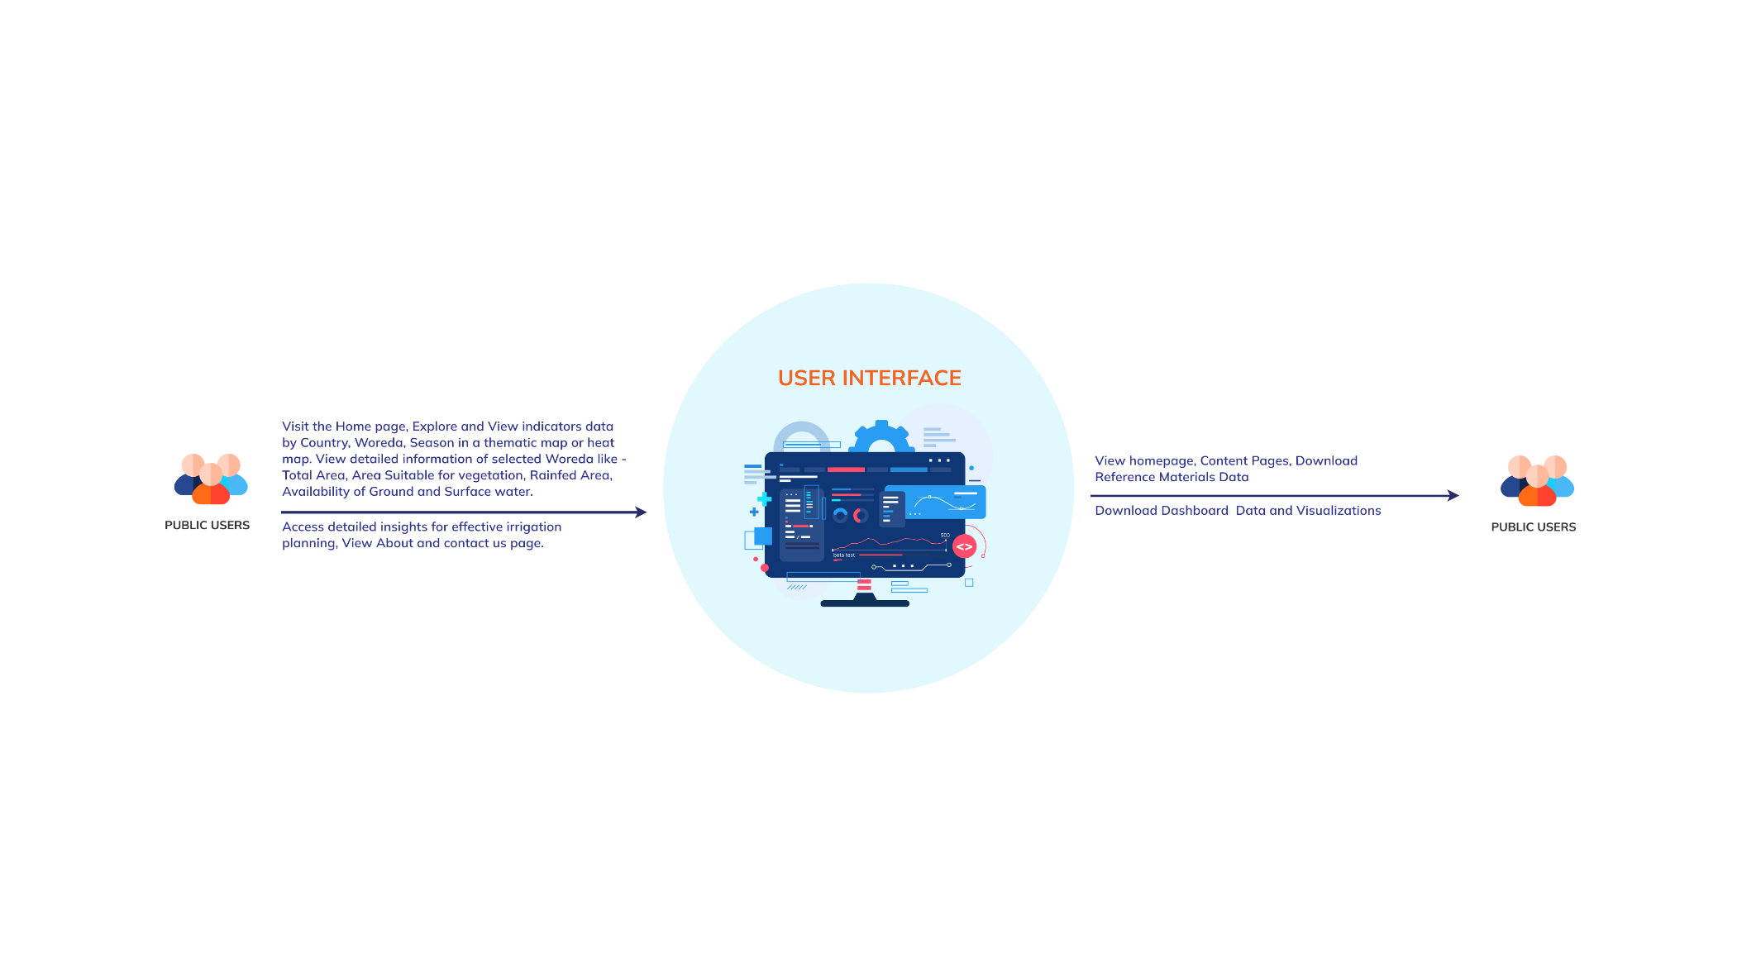**Level** **1 -User Interface**

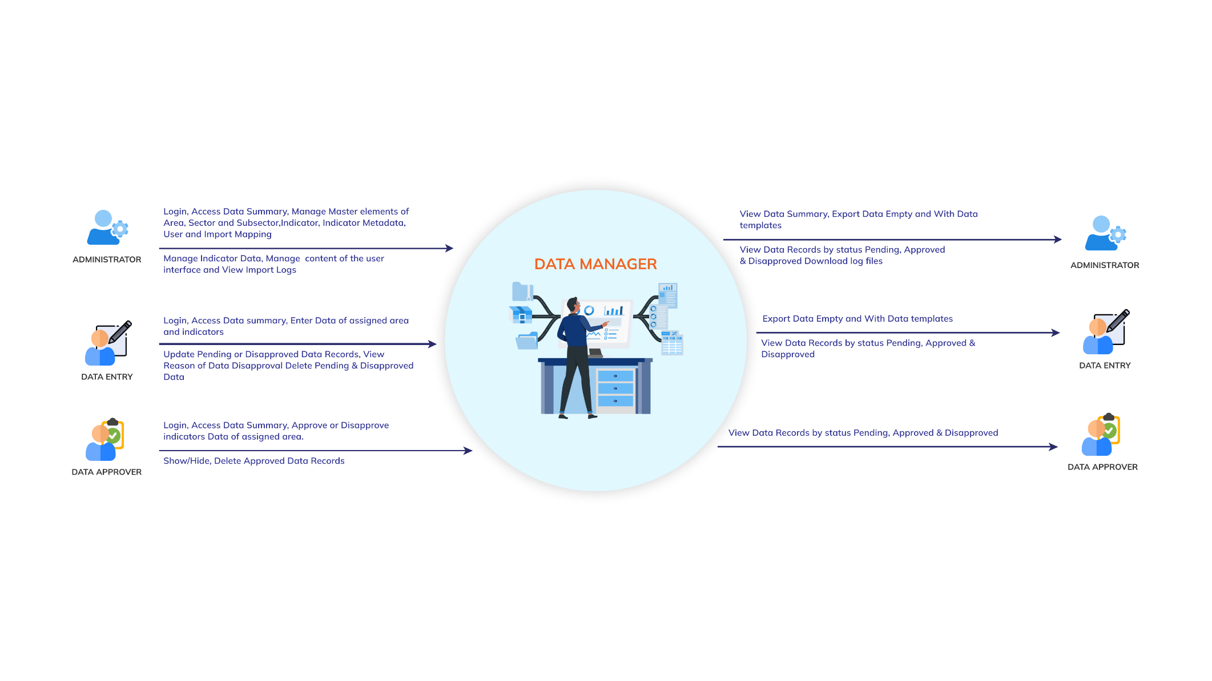**Level 2 – Data Manager**

# Annexure D: System Architecture

# Annexure E: Software Architecture

# Annexure F: System Screens

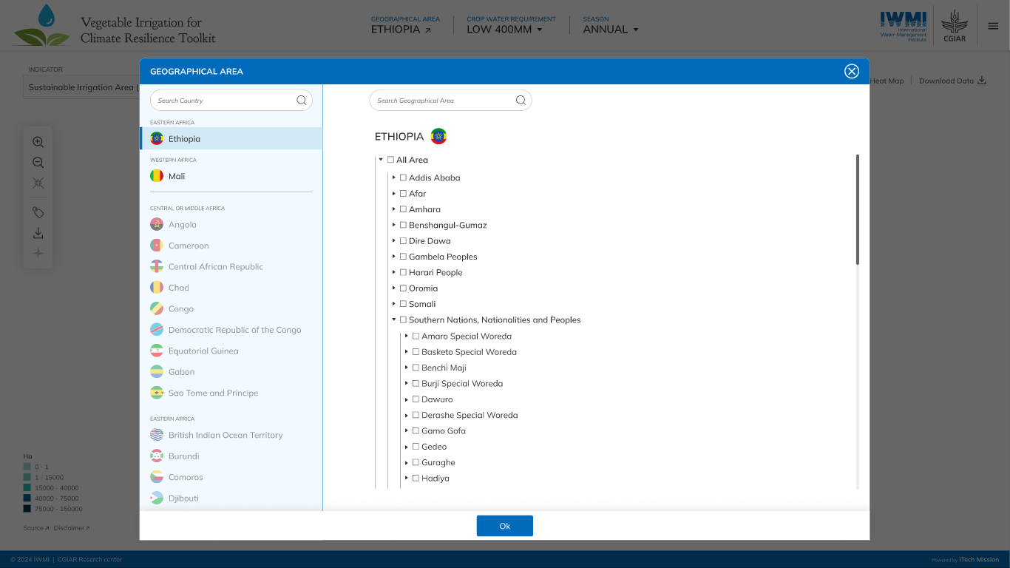

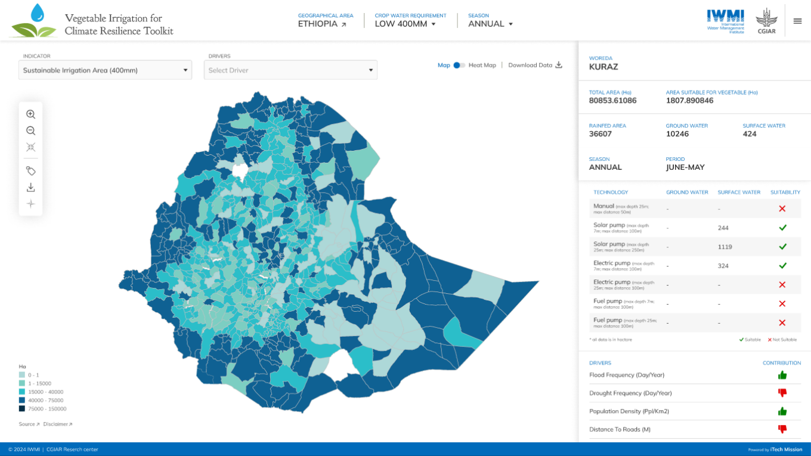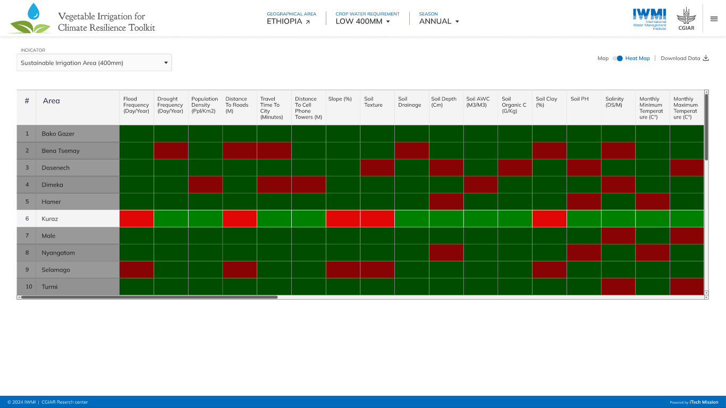

** End of the Document **